**BREAST CANCER DETECTION USING PATCH ANTENNA**

**A PROJECT REPORT**

***Submitted by***

**RAM KUMAR. S [211714106102]**

**RAVI VARMAN. V [211714106105]**

**SIVA PRASATH. M [211714106121]**

***in partial fulfilment for the award of the degree***

**of**

**BACHELOR OF ENGINEERING**

**in**

**ELECTRONICS AND COMMUNICATION ENGINEERING**

**RAJALAKSHMI INSTITUTE OF TECHNOLOGY,**

**CHENNAI 600 124**

**ANNA UNIVERSITY : CHENNAI 600 025**

**APRIL 2018**

**ANNA UNIVERSITY: CHENNAI 600 025**

**BONAFIDE CERTIFICATE**

Certified that this project report **“Breast cancer detection using patch antenna”** is the bonafide work **of “RAM KUMAR. S[211714106102],**

**RAVI VARMAN. V[211714106105]** and **SIVA PRASATH. M[211714106121]”** who carried out the project work under my supervision.

|  |  |
| --- | --- |
| **SIGNATURE**  Dr. G. R. SURESH M.E., Ph.D.,  **HEAD OF THE DEPARTMENT**  Professor  Department of Electronics and  Communication Engineering,  Rajalskhmi Institute of Technology,  Chennai – 600 124 | **SIGNATURE**  Ms.C. MALARVIZHI M.E.,  **SUPERVISOR**  Assistant Professor  Department of Electronics and Communication Engineering,  Rajalakshmi Institute of Technology,  Chennai – 600 124 |

**CERTIFICATE OF EVALUATION**

**College Name : 2117- Rajalakshmi Institute of Technology**

**Branch & Semester : Electronics and Communication Engg. VIII Semester**

**Subject : EC6811 PROJECT WORK**

**TITLE OF THE PROJECT:**

Breast Cancer Detection Using Patch Antenna

**NAME OF THE STUDENTS:**

**RAM KUMAR. S [211714106102]**

**RAVI VARMAN. V [211714106105]**

**SIVA PRASATH. M [211714106121]**

The report on the project work submitted by the above students in partial fulfillment for the award of the degree of Bachelor of Engineering in **ELECTRONICS AND COMMUNICATION ENGINEERING** of Anna University, reported the work done by the above students and then evaluated.

**The University Viva-voice was held on __________.**

**INTERNAL EXAMINER EXTERNAL EXAMINER**

**ACKNOWLEDGEMENT**

We wish to express our hearty and sincere gratitude to our chairman **Thiru. S. MEGANATHAN B.E., F.I.E.,** for his sincere endeavour in educating us in his premier institution.

We wish to express our deep gratitude to our beloved chairperson **Dr. (Mrs.) THANGAM MEGANATHAN M.A., M.Phil., Ph.D.,** for her enthusiastic motivation which helped us a lot in completing the project.

We express our thankfulness to **Dr. M . VELAN M.E., Ph.D.,** Principal, Rajalakshmi Institute of Technology, and the management for his kind support and the facilities provided to complete our work in time.

We express our sincere thanks to **Dr. G. R. SURESH, M.E., Ph.D.,** Professor and Head of the Department of Electronics and Communication Engineering, for his stupendous guidance and encouragement during this project.

We express our sincere thanks to our guide**, Ms. C. MALARVIZHI, M.E.,** Assistant professor, Department of Electronics and Communication Engineering, for leading us on the project. We thank him, for his erudite and enthusiastic guidance which reinforced and motivated us in completing the project successfully.

We extend our gratitude to **Mr. K. SIVAKUMAR, M.E., (Ph.D.),** Assistant Professor (SS), Project Coordinator, for his timely organization of reviews and his support throughout the project work.

Finally, we express our deep sense of gratitude to our parents and all our faculty members and all our friends for their constant encouragement and moral support.

**ABSTRACT**

In the today's world, communication systems using wireless technology is improving a lot and is the most widely researched area. This study of communication systems is incomplete without an understanding of the operations and techniques used in the antennas. Of these, there are many techniques that have been used to feed microstrip patch antennas. Edge feeding and inset feeding are the two among those techniques . We are chosen to compare edge feed and inset feed due to the advantage that it can be easily fabricated and simplicity in modelling as well as impedance matching. The functional characteristics and output parameters like VSWR, Return loss, Radiation pattern of these Microstrip Patch Antennas varies depending upon the technique used. Comparison of above mentioned parameters have been made on the basis of feeding on Microstrip Patch Antennas with their simulated performance characteristics. Both models have been designed and simulated in Advanced Design System (ADS) which is an electronic design automation software system.

**TABLE OF CONTENT**

|  |  |  |
| --- | --- | --- |
| **CHAPTER** | **TITLE** | **PAGE.NO** |
|  | **ABSTRACT** |  |
|  | **LIST OF FIGURES** |  |
|  | **LIST OF ABBREVIATIONS** |  |
| 1 | INTRODUCTION |  |
|  | 1.1 Overview | 1 |
|  | 1.2 Objective | 4 |
| 2 | LITERATURE REVIEW | 5 |
| 3 | METHODOLOGY |  |
|  | 3.1 Introduction | 17 |
|  | 3.2 Existing system | 17 |
|  | 3.3 Proposed system | 17 |
|  | 3.3.1 Block diagram | 18 |
|  | 3.3.2 Tools required | 18 |
|  | 3.3.3 Techniques | 18 |
|  | 3.3.4 Antenna implementation | 20 |
|  | 3.4 MATLAB | 21 |
|  | 3.4.1 Language of technical computing | 21 |
|  | 3.4.2 Language fundamentals | 22 |
|  | 3.4.3 Graphics | 22 |
|  | 3.4.4 Plotting basics | 22 |
|  | 3.4.5 SIMULINK | 22 |
|  | 3.4.6 Amplification | 23 |
|  | 3.5 SIGVIEW | 23 |
|  | 3.5.1 Concept | 24 |
|  | 3.5.2 Features | 24 |
|  | 3.6 B-Spline transformation | 26 |
|  | 3.6.1 Splines | 26 |
|  | 3.6.2 1D Splines | 27 |
|  | 3.6.3 Making a function from D-Spline | 28 |
|  | 3.6.4 Localization of changes | 29 |
|  | 3.6.5 Use in image registration | 30 |
|  | 3.6.6 Regularization | 31 |
|  | 3.7 Penalizes warping | 32 |
| 4 | RESULTS AND DISCUSSION | 33 |
|  | 4.1 MATLAB outputs | 33 |
|  | 4.2 Normal waveform | 33 |
|  | 4.3 Spline transformation | 35 |
|  | 4.4 Signal comparison  4.5 ADS outputs | 37  38 |
| 5 | CONCLUSION AND FUTURE WORK  APPENDICES | 39  40 |
|  | REFERENCE | 45 |

**LIST OF FIGURES**

|  |  |  |
| --- | --- | --- |
| **Fig. no** | **Description** | **Page no** |
| 3.1 | Implementation of antenna design | 20 |
| 3.2 | SIGVIEW | 24 |
| 3.3 | spline transformation | 26 |
| 3.4 | Cubic B-spline | 27 |
| 3.5 | Cubic B-spline, showing pieces extended beyond the knots | 28 |
| 3.6 | Sum of five shifted cubic B-spline | 29 |
| 3.7 | Demonstration of the localization of changes | 29 |
| 4.1 | Original signal of unaffected region | 33 |
| 4.2 | Original signal of affected region | 34 |
| 4.3 | Fractional spline wavelet transform of unaffected region | 35 |
| 4.4 | Fractional spline wavelet transform of affected region | 36 |
| 4.5 | Signal comparison and variation | 37 |
| 4.6 | ADS output | 38 |

**LIST OF ABBREVIATIONS**

|  |  |
| --- | --- |
| 1D | One dimensional |
| 2D | Two dimensional |
| 3D | Three dimensional |
| ADS | Advanced design system |
| EDA | Electronic device acquisation |
| EM | Electromagnetic |
| NB | Narrow band |
| PSO | Particle swarm optimization |
| RF | Radio frequency |
| SIGVIEW | Signal viewer |

**CHAPTER 1**

**INTRODUCTION**

**1.1 OVERVIEW:**

Breast tumor is one of the most life-threatening diseases and hence its detection should be fast and accurate. The medical imaging techniques such MRI, CT ,micro wave are used to detect tumour. However, due to grayscale noise tumour region in image are not properly visible. Hence we propose a antenna based approach to detect tumour cell less than 10mm

**MICROSTRIP OR PATCH ANTENNA:**

A microstrip Q factor patch antenna (also known as a rectangular microstrip antenna) is a type of radio antenna with a low profile, which can be mounted on a flat surface. It consists of a flat rectangular sheet or "patch" of metal, mounted over a larger sheet of metal called a ground plane. The most commonly employed microstrip antenna is a rectangular patch which looks like a truncated transmission line. The dielectric loading of a microstrip antenna affects both its radiation pattern and impedance bandwidth. As the dielectric constant of the substrate increases, the antenna bandwidth decreases which increases the of the antenna and therefore decreases the impedance bandwidth. Microwave design and simulation tools provide the most complete solution for creating robust designs with first-pass success and high yields. ADS provides accurate models and powerful simulation technologies for circuitto system-level designs. Seamlessly integrated circuit and EM simulation tools flow from schematic entry to production and verification. A complete set of the most accurate wireless verification tools in ADS provides true circuit verification to all wireless standards. There are several techniques available to feed or transmit electromagnetic energy to a microstrip patch antenna. The role of feeding is very important in case of efficient operation of antenna to improve the antenna input impedance matching.

**PROPERTIES OF ANTENNA:**

The most important properties possessed by many antennas are polarization, radiation pattern. Directivity and power gain, radiation resistance, band width, effective aperture, power transfer and reciprocity.

**POLARIZATION:**

An electromagnetic wave launched from an antenna, may be vertically or horizontally polarized. The direction of the electric field specifies the polarization of the antenna. If the electric field is parallel to the earth electromagnetic wave is said to be horizontally polarized. If the electric field is perpendicular to the earth, the electromagnetic wave is said to be vertically polarized.

Antennas that are horizontal to the earth produce horizontal polarization while antennas that are vertical in the earth produce vertical polarization. For optimum transmission and reception both the transmitting and receiving antennas must be of the same polarization.

Electromagnetic waves are usually vertically polarized though other types of polarization may also be used for specific purposes. Vertical or horizontal polarization is also called linear polarization. Circular polarization refers to a combination of vertical and horizontal polarization.

In a receiving system, the polarization of the antenna and incoming wave need to be matched for maximum response. If this is not the case there will be some signal loss, known as polarization loss. For example, if there is a vertically polarized wave incident on a horizontally polarized antenna, the induced voltage available across its terminal will be zero. In this case, the antenna is cross polarized with an incident wave. The square of the cosine of the angle between wave polarization and antenna polarization is a measure of the polarization loss. It can be determined by squaring the scalar product of unit vectors representing the two polarizations.

**RADIATION PATTERN(POLAR PATTERN):**

This is a graphical plot of the field strength radiated by the antenna in different angular directions. The plot may be obtained for the vertical or horizontal polar patterns respectively. A wide variety of polar patterns are possible such as: The omni-directional pattern in which energy is radiated equally in all directions , The pencil beam pattern in which energy is concentrated mainly in one direction , The multiple beam pattern in which energy is radiated in several adjacent beams , The same polar patterns apply whether the antenna is transmitting or receiving radiation because of the principle of reciprocity.

**DIRECTIVITY AND GAIN:**

The directivity of an antenna is a measure of the ability to direct RF energy in a limited direction rather than in all (spherical) directions equally. The directivity of an antenna refers to the narrowness of the radiated beam. If the beam is narrow in either the horizontal or vertical plane, the antenna has a high degree of directivity in that plane. The power gain of an antenna increases as the degree of directivity increases because the power is concentrated into a narrow beam. The term gain implies that the antenna creates a higher power when it concentrates the power into a single direction. Directivity gain is the gain calculated assuming a loss less antenna in a preferred direction at maximum radiation.

**1.2 OBJECTIVE:**

The objective of this project to detect the Breast tumor using the antenna as a sensor. The antenna with minimal microwave radiation place above the breast phantom to detect cancer cell. Cancer cell if diagnosed when the size is less than 10mm can be treated with tablet.

**CHAPTER 2**

**LITERATURE REVIEW**

**2.1 INTRODUCTION:**

A literature survey, or literature review, means that anyone could read and report on what the literature in the field has to say about the topic or subject. There may be a lot of literature on the topic or there may be a little either way. The goal is to show that author have read and understand the positions of other academics who have studied the problem/issue that author is studying and include that in the paper or project. The author can do this by way of comparing and contrasting, simple summarization, or any numbers of ways that show that author have done the research. This chapter reviews some similar previous work, related journals and researches which include cognitive radio sensing that can contribute an ideas for completing this project. This chapters also will discuss about the efficient spectrum usage for secondary users . This chapter is very important to know the efficient usage of the spectrum for secondary user and to get a better sensing compared to the normal sensing methods.

**Microwave Hyperthermia for Breast Cancer Treatment Using Electromagnetic and Thermal Focusing Tested on Realistic Breast Models and Antenna Arrays (Phong Thanh Nguyen, Amin Abbosh, Senior Member, IEEE, and Stuart Crozier.,)**

A technique for noninvasive microwave hyperthermia treatment for breast cancer is presented. In the proposed technique, electromagnetic focusing on patient-specific breast models is implemented to concentrate the power at the tumor position while keeping the power levels at other positions (healthy tissues) at minimum values. This step is realized by optimizing phase excitations of the utilized antenna elements. In the next step, a thermal analysis is used to determine the scaling factor of the antennas’ excitation amplitudes to realize the required temperature at the tumor position. A closed-loop procedure ensures that there are no hot spots in any of the healthy tissues. The technique is tested in a realistic environment which includes three-dimensional breast models and antenna arrays. The presented results on fatty and dense breast models using two types of directional antennas validate the proposed technique. The investigations across wide frequency bands indicate that the frequencies around 4.2 GHz and 4.5 GHz are optimum values for the hyperthermia treatment of dense and fatty breasts, respectively. The aim of this work is to raise the temperature to above 42℃ in a volume of 1 0 at the tumor location, while maintaining normal temperature at the healthy breast tissues. In our study, CST Microwave Studio was chosen for the simulations. It includes the co-simulation of EM focusing and thermal analysis. Our strategy is to first perform EM focusing to obtain the optimized excitation phases for the antennas using the Trust Region Framework. The thermal analysis is then carried out to optimize the scaling factors for each sub-array to produce the desired temperature at the target location. In this step, the EM and thermal simulations are coupled together. The simulations are stopped when the steady state temperature achieves the desired value at the tumor location while confirming that the temperature at the other locations is at the normal levels. The final temperature distribution is realized using an appropriate scale factor, which is accordingly used to compute the required excitation amplitudes for the antennas.

**Microstrip Near-Field Focusing for Microwave Non-invasive Breast Cancer Thermotherapy(Long Wang1, Dixiang Yin1, Meng Li1 and Lewei Li1)**

In this paper, a novel focusing method in non-invasive microwave thermotherapy for breast cancer is proposed. Since the antennas used in the non-invasive microwave thermotherapy devices are no longer working as a far field transmitter, only its near field characteristics are critical to the performance of the system, design methods and principles have to be refreshed towards a better thermotherapy device.The method proposed in this paper focuses on the application of microstrip structure in these systems, is based on the nature of near field characteristic of microstrip antenna, thus to enhance the energy density of the target area. This novel device will achieve near field focusing effect by using single antenna, instead of antenna array, lenses or other methods that are usually utilized in communication systems. The focusing effect is verified and demonstrated by well-designed numerical experiments, and the results show that this method is very promising in the treatment of breast cancer. Microwave thermotherapy is a promising method towards the fighting against breast cancer, along with standard treatments include surgery, radiation therapy, chemotherapy, and hormonal therapy[1]. An invasive thermotherapy can achieve high-efficiency much more easily than a non-invasive one, because of that the invasive device is put in the middle of the target area to literately heating the cancer tumor from inside. However, non-invasive therapy will be more attractive considering the potential scars leave on patients’ skin in invasive therapies, along with the cost and other drawbacks. Also, it can be equally efficient if the non-invasive therapy evolved into a focused one. Focusing microwave systems usually utilize phased array techniques, which will end up with a very complex system[2]. It is also valid with other recent progresses such as time-reversal focusing system[3]. In our group, several schemes of microwave thermotherapy system have been studied[4-7] including both invasive and non-invasive thermotherapies. In this paper, a focusing method is proposed for conformal microstrip microwave breast cancer thermotherapy.

**Focused Microwave Thermotherapy: a PatientSpecific Numerical Assessment of a Non-Invasive Breast Cancer Treatment(D.A.M. Iero, T. Isernia Dipartimento di Informatica, Matematica, Elettronica e Trasporti (DIMET) Università Mediterranea di Reggio Calabria Reggio Calabria, Italy,L.Crocco I. Catapano Istituto per il Rilevamento Elettromagnetico dell'Ambiente (IREA) Consiglio Nazionale delle Ricerche (CNR) Napoli, Italy.)**

Thermotherapy, as well as any cancer treatment, requires a strict selectivity in order to avoid undesired injurious effects against healthy tissues. In this paper, we provide a computational study concerning a new focusing technique, for hyperthermic treatment design, based on the recent method for the synthesis of pencil beams by means of fixed-geometry arrays [6]-[7]. Performances are tested against 2-D anatomically realistic breast phantoms, showing an interesting potential. In this paper we provide a detailed electromagnetic (EM) and thermal computational study of a non-invasive hyperthermic treatment for breast cancer. Such a treatment is designed according a synthesis technique such to guarantee the maximum power deposition in a given (tumoral) target while keeping it below predetermined levels in healthy tissues, thus preserving them against undesired heating. , thermal analysis has been realized by computing the heating potential distribution corresponding to a multi-frequency radiation. The corresponding temperature spatial distribution, shown in Fig., demonstrates that the hyperthermic treatment is well focused onto the target point since no mismatch occurs there. The computational study illustrates the potential of an array synthesis technique in designing the applicator of an effective non-invasive patient-specific microwave hyperthermic system. Casting the focusing problem as a constrained CP one means assuming intrinsically the full knowledge of the scenario at hand. Therefore, it would be interesting to extend the analysis to a wider range of breast typology, tumor locations counteracting the diagnostic inaccuracy in reconstructing the interest domain. A depth discussion on such an issue is left to forthcoming contributions.

**MICROWAVE TECHNIQUES IN THE DIAGNOSIS AND TREATMENT OF CANCER(Jochen Edrich.C,)**

Naturally emitted thermal radiation of the human body at cm and mm wavelengths can be utilized to image subcutaneous temperature distributions and detect thermally active tumors. Contacting thermographs that were developed for such point-by-point measurements at long cm wavelengths are compared with remotely focussed ,imaging thermographs for short cm and mm wavelengths in regard to instrumentation, measurement methods and clinical results in the detection of breast cancer and other tumors. For treatment of cancer microwave irradiation can produce hyperthermia in a more localized region than conventional methods. Various forms of controlling hyperthermia using subcutaneous problems are discussed, and potentials, preliminary animal experiments and limitations of new forms of non invasive controls using microwave radiometry are given.

**Microwave Breast Cancer Hyperthermia using Deformable Mirror (Kavitha Arunachalam*, Satish S Udpa and Lalita Udpa Department of Electrical and Computer Engineering, Michigan State University, East Lansing, MI.,)**

Breast cancer is the second leading cause of cancer deaths amongst women and it is anticipated that one in every eight American women will succumb to breast cancer before the age of 90. In recent years, hyperthermia has been suggested as an alternate adjuvant therapy to radiation and chemotherapy treatment of breast cancer [1-2]. Clinical prototypes developed for RF hyperthermia often employ a phased array or multiple antenna arrangement to elevate the temperature at the tumor site for selective tissue heating [3-5]. We propose in this paper, an alternative mode of hyperthermia treatment using a deformable membrane mirror. The deformable mirror with reflective coating functions as an adaptive focusing mirror and delivers preferential energy deposition at the tumor site in the breast. The proposed hyperthermia technique is devoid of the complexities associated with other RF approaches such as the need for the control of amplitude and phase of the antenna array elements for regional focusing. An alternate microwave hyperthermia treatment for breast cancer is presented. The proposed technique employs a deformable membrane mirror to focus the incident EM field towards the target tumor and achieves selective tumor heating sparing the surrounding benign tissue. With the help of a simple search algorithm, the potential distribution applied to the mirror actuator array can be adjusted in a feedback loop to focus the EM field to desired depths. The deformable mirror hyperthermia assembly with a single fixed microwave source supplements the functionality of the phased arrays and multiple antennas used in conventional RF hyperthermia techniques.

**A Computational Study of Ultra-Wideband Versus Narrowband Microwave Hyperthermia for Breast Cancer Treatment(Mark Converse, Member, IEEE, Essex J. Bond, Member, IEEE, Barry D. Van Veen, Fellow, IEEE, and Susan C. Hagness, Senior Member, IEEE., )**

It gives a computational study comparing the performance of narrowband (NB) microwave hyperthermia for breast cancer treatment with a recently proposed ultra-wideband (UWB) approach. Space–time beamforming is used to pre process input signals from both UWB and NB sources. The train of UWB pulses or the NB sinusoidal signals are then transmitted simultaneously from multiple antennas into the breast. Performance is evaluated using ﬁnite-difference time-domain electromagnetic (EM) and thermal simulations with realistic numerical breast phantoms derived from magnetic resonance images (MRIs) of the breast. We use three methods of mapping MRI data to complex permittivity data to account for uncertainty in the embodiment of the dielectric properties transitions in heterogeneous breast tissue. EM power-density deposition proﬁles and temperature proﬁles are compared for the UWB and NB cases in the three different breast phantoms. Dominant mechanisms that inﬂuence the efﬁcacy of focusing UWB and NB signals in the breast are identiﬁed. The results of this study suggest that, while NB focusing performs reasonably well when the excitation frequency is optimized, UWB focusing consistently performs better, offering the potential for tighter focusing and greater reduction of hot spots, particularly in breast tissue, which exhibits distinct dielectric-properties boundaries within the tissue heterogeneity. In this study, we have compared UWB and NB beamforming for microwave hyperthermia treatment of breast cancer using anatomically realistic numerical breast phantoms containing a 2-mm-diameter tumor. Three methods for mapping MRI pixel intensity data to complex permittivity data were used to derive the phantoms. These mapping methods cover a wide range of possible embodiments of the dielectric-properties transitions that may occur in the breast interior due to heterogeneous tissue composition .The small tumor size creates one of the most challenging focusing scenarios for selective heating. This formal comparison study conﬁrms our hypothesis that UWB focusing methods offer the potential for tighter focusing and a greater reduction of hot-spots compared to NB methods for a small ( 1 cm) tumor size. The results demonstrate that UWB focusing consistently produces the necessary temperature gradients required for effective hyperthermia treatment while preserving normal physiological temperatures throughout larger regions of normal tissue relative to NB focusing with an optimum excitation frequency, particularly in breast tissue environments that exhibit distinct dielectric-properties boundaries between fat and ﬁbro glandular tissue.

**Time Reversal Based Microwave Hyperthermia Treatment of Breast Cancer(Bin Guo, Luzhou Xu, and Jian Li Department of Electrical and Computer Engineering University of Florida, P.O. Box 116130 Gainesville, FL 32611, USA.,)**

In this correspondence, a new time reversal (TR) based ultra-wideband (UWB) microwave method for hyperthermia treatment of breast cancer is presented. Two high-resolution techniques, time reversal (TR) and robust Capon beamformer (RCB), are employed to shape the transmitted signals both temporally and spatially. As shown in the two-dimensional (2D) numerical simulations, this method has better electromagnetic (EM) energy focusing ability than the existing methods, and can provide the necessary temperature gradients required for effective hyperthermia. We demonstrate the performance of our TR-RCB method via several numerical examples. For comparison purposes, the space-time beamforming method is also applied to the same models. The average input power for the antenna array is 4.2 W/cm, and the treatment time is 5 minutes. when the proposed TR-RCB and space-time beamforming method are used, respectively. The temperature distributions within the horizontal breast models using the TR-RCB and space-time beamforming method, respectively. As we can see, the proposed TR-RCB method can elevate the temperature of the target region greater than 42◦C while maintaining the temperatures of the healthy regions below 42◦C. We also note that the proposed TR-RCB method provides better temperature selectivity than the spacetime beamforming method. We have presented a new UWB method for microwave hyperthermia treatment of breast cancer employing the time reversal and robust Capon beamforming techniques. As shown in the 2D numerical simulations, this new method has better EM energy focusing ability than the existing ones, and can provide the necessary temperature gradients required for effective hyperthermia treatment of breast cancer.

**ADAPTIVE FOCUSING EXPERIMENTS FOR MINIMALLY INVASIVE MONOPOLE PHASED ARRAYS IN HYPERTHERMIA TREATMENT OF BREAST CANCER(Alan J. Fenn, Augustine Y. Cheungt, Hongren Caot Lincoln Laboratory, Massachusetts Institute of Technology, Lexington, Massachusetts 02173-0073 tCheung Laboratories, Columbia, Maryland 21046- 1705.,)**

In order to treat breast cancer with hyperthermia, it is some- times desirable to heat large volumes of tissue such as a quad- rant of the breast. A number of microwave phased array applicators are under investigation for heating large tissue volumes. A minimally invasive monopole phased array applicator has recently been developed to heat breast tumors using adaptively focused 915 MHz microwave energy . This paper reviews the design and potential use of monopole phased arrays in heating compressed breast tissue. Computer simulations of the monopole phased arrays indicate desirable focused electric-field patterns are achieved in compressed breast tissue. To measure the monopole array performance, prototype applicators and compressed breast phantom models were fabricated. Tests were performed with and without adaptive feedback, and good agreement with simulations is obtained.The design, computer simulations, and phantom experiments for a non invasive monopole phased array hyperthermia applicator have been described, A ray-tracing analysis is used to predict the ideal performance of dual monopole arrays on opposite sides of homogeneous compressed breast tissue. In both low-power tests and high-power tests, focused beam patterns were achieved. The simulated and measured phantom electric- field data indicate that 915 MHz non invasive monopole phased arrays, with adaptive feedback focusing, may have potential application for hyperthemia treatment of tumors in compressed breast tissue and similar tissues.

**Thermal and Microwave Constrained Focusing for Patient-Speciﬁc Breast Cancer Hyperthermia: A Robustness Assessment (Domenica A. M. Iero, Lorenzo Crocco, Senior Member,IEEE, and Tommaso Isernia.,)**

In this paper, we address the problem of microwave hyperthermia. In particular, we ﬁrst introduce simple tools to understand the relationship between thermal and electro magnetic power focusing. Then, we assess the electromagnetic and thermal performances of a recently proposed strategy to design array applicators. Contrary to common approaches, such a strategy allows a punctual control of power deposition, which is crucial for effective treatment planning. With respect to breast cancer hyperthermia, we analyze the robustness of the strategy against inaccuracies based on the knowledge of the scenario, in a quantitative manner. This analysis allows us to draw useful guide lines on the accuracy of patient-speciﬁc information required to guarantee the effectiveness of treatment. HYPERTHERMIA, also known as thermotherapy, is a cancer treatment based on selective tumor exposure to high temperatures (43 C to 45 C). Thanks to its cytotoxic effects, hyperthermia may either counteract malignant tumors [1] or increase the effectiveness of cancer therapies, for example, radiotherapy and chemotherapy [2]. As in any cancer treatment, selectivity is crucial to protect surrounding healthy tissues; therefore, an accurate planning of the treatment and an optimal design of the applicator are essential [3]. Thanks to their capability of shaping the induced power deposition, microwave antenna arrays have been broadly addressed as convenient applicators to convey energy to the treated areas. It is now recognized that hyperthermia treatments need patient-speciﬁc and optimized planning tools [3]. However, development of the latter is not at all straightforward because of the complex relationship existing between the array excitations and the resulting temperature distribution. In this paper, the thermal-focusing problem underlying hyperthermia has been tackled in detail. Then,a performance analysis has been carried out for the OCPF [8],[12],[13],a recently proposed strategy that is able to focus the electromagnetic ﬁeld and preserve healthy tissues. In particular, efforts have been devoted to understand the conditions that ensure the effectiveness of OCPF-based planning tool sand treatment .An extensive numerical study has been performed to this end to quantify the accuracy that is needed in the knowledge of the patient-speciﬁc scenario .The analysis has appraised both electromagnetic performances and robustness, as well as thermal effects.

**Multi-Frequency Constrained SAR Focusing For Patient Speciﬁc Hyperthermia Treatment (Gennaro G. Bellizzi Student Member, IEEE, Lorenzo Crocco Senior Member, IEEE, Giada M. Battaglia, Tommaso Isernia Senior Member, IEEE.,)**

In Hyperthermia treatments, the possibility of generating a speciﬁc absorption rate distribution peaked into the tumor and bounded elsewhere represents the main clinical need. As multi-frequency applicators can be exploited to reduce occurrence of undesired hot-spots, an optimal multi-frequency approach is proposed and discussed. Being formulated in terms of a convex programming problem, the globally optimal solution can be determined (but for very special cases). The procedure, presented for the case of scalar ﬁelds, can be extended both to the case of vector ﬁelds and to the more interesting problem of shaping (rather than just focusing) the Speciﬁc Absorption Rate distribution. A relatively simple and effective multi frequency procedure for HT treatment planning has been presented. The procedure relies on the FOCO formulation for monochromatic ﬁelds and takes advantage from the adoption of multi-frequency applicators (with different excitations at the different frequencies). By exploiting more frequencies, the mf-FOCO allows to achieve a better separation between the main SAR peak and the secondary ones. Notably, the method allows to enforce arbitrary constraints on the power deposition outside the target area and takes advantage from a convenient CP formulation. As such, an optimized loco-regional control of the spatial SAR distribution (where sharpness is the goal) is achieved .The developed tools will help to identify the optimal conﬁguration, as well as the ultimate performances. As for as the number of antennas is concerned, let us note that even if the adopted one may seem large, it is a common practice in the radar industry to deal with fully active arrays (with independent control of amplitude and phase) having a number of antennas and ampliﬁers much larger than that. The formulation and validation have been given for the case of scalar ﬁelds. The extension to the case of vector ﬁelds, while conceptually simple, implies paying a price in terms of computational burden. By the way, scalar ﬁelds are of interest in several applications such as the case where one component of the ﬁeld is dominant above the others as well as in the case of ultrasound waves in biological media.

**CHAPTER 3**

**METHODOLOGY**

**3.1 INTRODUCTION:**

In this chapter, the existing model and proposed model, block diagram of the project are going to be discussed along with the detailed description of proposed tools with their feature.

**3.2 EXISTING SYSTEM:**

The exiting system uses particle swarm optimization (PSO) method to detect optimal point to treat breast cancer.The antenna operates at 4.2 GHz and heat the cancer cell at 42 degree celcius to treat the cancer cell.

**3.3 PROPOSED SYSTEM:**

We propose a new antenna design with different operating frequencies to detect cancer cells less than 10mm.The antenna emits minimal radiation compared to conventional systems.Earlier diagnosis of cancer enables physicians to treat cancer cell with tablets and eliminate the need for surgery and chemotherapy.

**3.3.1 BLOCK DIAGRAM OF THE PROPOSED SYSTEM:**

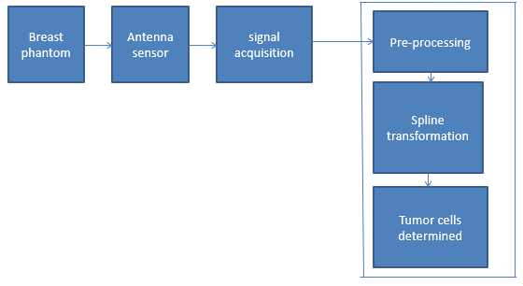

**3.3.2 TOOLS REQUIRED:**

1)ADS2011

2)Matlab2017b

3)Sigview

4)Breast Phantom

5)Class D Amplifier

**3.3.3 TECHNIQUES :**

The feeding techniques used in the microstrip antenna are divided into two important classes as given below:-

Contacting Feed- In this method, the patch is directly fed with RF power using the contacting element such as microstrip line or coaxial line. The most commonly used contacting fed methods are Microstrip Feed and Co-Axial Feed.

Non-Contacting Feed- In this method, the patch is not directly fed with the RF power but instead power is transferred to the path from the feed line through electromagnetic coupling. The most commonly used non-contacting feed methods are Aperture Coupled feed and Proximity Coupled Feed.

An antenna is a conductor or group of conductors used for radiating electromagnetic energy into space or collecting electromagnetic energy from space. When radio frequency signal has been generated in a transmitter, some means must be used to radiate this signal through space to a receiver. The device that does this job is the antenna. The transmitter signal energy is sent into space by a transmitting antenna and the radio frequency energy is then picked up from space by a receiving antenna. The radio frequency energy that is transmitted into space is in the form of an electromagnetic field. As the electromagnetic field arrives at the receiving antenna, a voltage is induced into the antenna. The radio frequency voltage induced into the receiving antenna is then passed into the receiver. There are many different types of antennas in use today but emphasis is on antennas that operate at microwave frequencies. This chapter discusses the two major types microwave antenna which are the horn-reflector and parabolic dish antennas. Microwaves refer to radio waves with wavelength ranging from as long as one meter to as short as one millimeter or equivalently with frequencies between 300MHZ (0.3GHZ) and 300GHZ.Let us see about the feeding types of our antenna design to overcome the problems,A feedline is used to excite to radiate by direct or indirect contact. There are many different methods of feeding and four most popular methods are microstrip line feed, coaxial probe, aperture coupling and proximity coupling.

Edge Feed is one of the easier methods to fabricate as it is a just conducting strip connecting to the patch and therefore can be consider as extension of patch. It is simple to model and easy to match by controlling the inset position. The disadvantage of this method is that as substrate thickness increases, surface wave and spurious feed radiation increases which limit the bandwidth. Since the above mentioned antenna yields a high input impedance, there is some modification made in the feed. Since the current is low at the ends of a half-wave patch and increases in magnitude towards the centre, the input impedance could be reduced if the patch was fed closer to the centre.Let us see the design system used here for the antenna used, Advanced Design System (ADS) is the world’s leading electronic design automation (EDA) software for RF, microwave, and high speed digital applications. In a powerful and easy-to-use interface, ADS pioneers the most innovative and commercially successful technologies, such as X-parameters* and 3D EM simulators, used by leading companies in the wireless communication and networking and aerospace and defense industries.

**ANTENNA IMPLEMENTATION:**

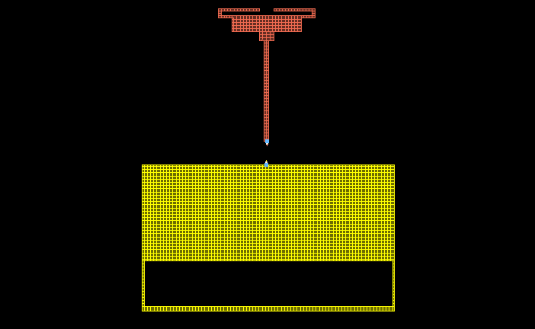

**Fig. 3.1 implementation of antenna design**

**3.4 MATLAB:**

MATLAB (matrix laboratory) is a multi-paradigm numerical computing environment and fourth-generation programming language. A proprietary programming language developed by MathWorks, MATLAB allows matrix manipulations, plotting of functions and data, implementation of algorithms, creation of user interfaces, and interfacing with programs written in other languages, including C, C++, Java, Fortran and Python.

Although MATLAB is intended primarily for numerical computing, an optional toolbox uses the MuPAD symbolic engine, allowing access to symbolic computing capabilities. An additional package, Simulink, adds graphical multi-domain simulation and model-based design for dynamic and embedded systems.

**3.4.1 THE LANGUAGE OF TECHNICAL COMPUTING:**

MATLAB is a high-level language and interactive environment for numerical computation, visualization, and programming. Using MATLAB, you can analyze data, develop algorithms, and create models and applications. The language, tools, and built-in math functions enable you to explore multiple approaches and reach a solution faster than with spreadsheets or traditional programming languages, such as C/C++ or Java. You can use MATLAB for a range of applications, including signal processing and communications, image and video processing, control systems, test and measurement, computational finance, and computational biology. More than a million engineers and scientists in industry and academia use MATLAB, the language of technical computing.

**3.4.2 LANGUAGE FUNDAMENTALS:**

Syntax, operators, data types, array indexing and manipulation

MATLAB is an abbreviation for "matrix laboratory." While other programming languages usually work with numbers one at a time, MATLAB operates on whole matrices and arrays. Language fundamentals include basic operations, such as creating variables, array indexing, arithmetic, and data types.

**3.4.3 GRAPHICS:**

Two- and three-dimensional plots, images, animation, visualization.Graphics functions include 2-D and 3-D plotting functions to visualize data and communicate results. Customize plots either interactively or programmatically.

**3.4.4 PLOTTING BASICS:**

**2-D and 3-D Plots**

Plot continuous, discrete, surface, and volume data.Use plots to visualize data. For example, you can compare sets of data, track changes in data over time, or show data distribution. Create plots programmatically using graphics functions or interactively using the **Plots** tab at the top of the MATLAB desktop.

**3.4.5 SIMULINK:**

Simulink Report Generator lets you design and generate richly formatted Microsoft Word, HTML, and PDF reports from Simulink models and simulations. The report generator lets you automatically create artifacts for Model-Based Design, such as system design descriptions and generated code, requirements traceability, and testing reports. You can publish these artifacts in an interactive web format that colleagues can use without opening the model. You can compare Simulink models, review comparison results in an interactive XML report, and merge model differences.

Simulink Report Generator produces artifacts for DO-178, ISO 26262, IEC 61508, and related industry standards.

A signal conditioner is a device that converts one type of electronic signal into a another type of signal. Its primary use is to convert a signal that may be difficult to read by conventional instrumentation into a more easily read format. In performing this conversion a number of functions may take place.

Analog signal conditioners are designed to isolate, transmit, convert, split, and amplify analog signals in harsh industrial environments in order to improve the reliability of your process. These signal conditioners save panel space, provide isolation via galvanic isolation, solve mismatched signal issues, standardize on a signal type, reduce wiring with loop powered units, and improve troubleshooting.

**3.4.6 AMPLIFICATION:**

When a signal is amplified, the overall magnitude of the signal is increased. Converting a 0-10mV signal to a 0 -10V signal is an example of amplification.

**3.5 SIGVIEW:**

SIGVIEW is real-time and offline signal analysis software package with wide range of powerful signal analysis tools, statistics functions and a comprehensive visualization system. SIGVIEW is highly customizable and flexible but does not require any programming know-how.

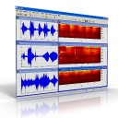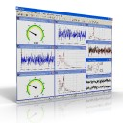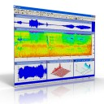

**Fig. 3.2 sigview outputs**

**3.5.1 CONCEPT:**

With its unique user interface and philosophy, SIGVIEW gives you the absolute freedom to combine different signal analysis methods in any possible way - there are almost no artificial rules and limitations. Once you get the basics, everything else in SIGVIEW follows the same logical pattern.

**3.5.2 FEATURES:**

Support for wide range of **data acquisition devices**, from common **sound cards**to **professional DAQ** devices. Various options for triggering, decimation and file-logging are included. The following device types are supported:                        

**Real time** data display, signal analysis and control. You can work with live signals and observe results immediately.

**Import and export** of signal files in numerous formats: WAV, MP3, ASCII, WMA, AU, AIFF, SND, 8/16/32-bit binary files, EDF...

**Optimized FFT algorithm** with fine parameter tuning and various **pre and postprocessing options** windowing, zero-padding, power spectrum and PSD, automatic averaging, test for spectral peaks integrity,...

**Spectrogram and Time-FFT** functions with powerful graphical display solutions

Dual channel (**cross-spectral**) analysis (cross spectrum, coherence, cross correlation,...

Real-time **arithmetics** on signals (subtract, multiply, add, scale, normalize...)  

**Various statistics functions**: peak hold, averaging, smoothing, removing linear trend, probability distribution... Analog-style instruments for real-time display of important signal parameters

**Custom filter curves** can be freely defined and applied directly to time-domain signal or to the calculated spectrum

**Advanced signal display** and handling options: unlimited overlays, unlimited number of markers and annotations for each signal, parallel signal display (EEG style), cut/copy/paste signal parts, unlimited zoom levels, VCR-style commands for audio playing,... 

**Signal generator** including sine signal, white and pink noise, step signal, sweep signal,...

**No** **artificial** or license-based **limitations**: million points FFTs can easily be calculated; dozens of signals can be combined and analyzed at the same time. 

**Field-proven**by thousands of satisfied users. See our [Reference](http://www.sigview.com/about.htm)list for some examples.

**3.6 B-SPLINE TRANSFORMATION:**

IB

IA

IBT

T

**Fig. 3.3 splines**

As for polynomial and thin-plate-spline transformations, T goes from the transformed image back to the untransformed image, again because it is difficult to find the inverse.

**3.6.1 SPLINES:**

In common usage, the word “spline” means any shape that smoothly passes through a set of points. Thus, it is a smooth interpolating function. As we did for the polynomial transformations and for the thin-plate splines, we will consider such a set of points to be the *x’* coordinates, or the *y’* coordinates, or the *z’* coordinates in the transformation in the figure above, and each fitting is treated as a separate problem. Thus, at a small set of points *x,y,z* in the space of image IA, we specify a value for *x’*. Then we use a spline to interpolate those points. We repeat that process for *y’* and for *z’*. Then we use the values of the *x* spline to specify *x’* at other points in IA, and use the *y* spline for *y’* and the *z’* spline for *z’*. This simplifies the problem one of a mapping from 3D space to 3D space into a three mappings from 3D space into 1D space.

**3.6.2 1D splines:**

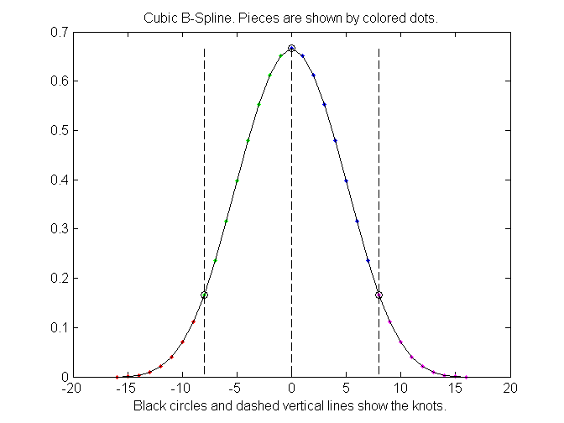 It is easy to understand 2D and 3D B-splines as combinations of 1D splines. So we start with 1D.The most important feature of a spline is that it is a function that is non-zero over only a small region of space. That region is divided into a set of sub regions, and the B-spline is equal to a polynomial over each sub region.

Fig. 3.4 Cubic B-spline

The vertical dashed lines separate the plot into four regions, and the curve in each region is a polynomial. Each of these four polynomials is cubic, and as a result, this spline is called a “cubic B-spline”. (“B-spline is short for “basis spline”.) The points at which the pieces join are called “knots”, and that term may refer to the positions on the function given by the black circles or to the *x* values, where the vertical dashed lines intersect the horizontal axis.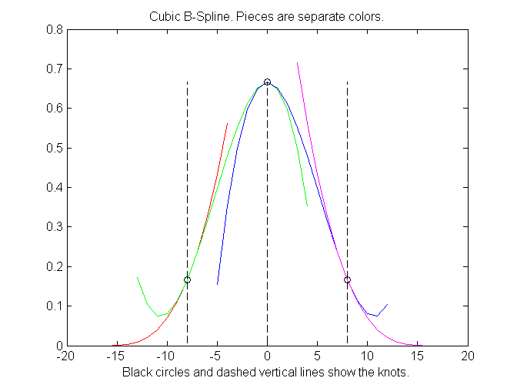The four pieces meet so smoothly that it may seem as if the entire spline is one polynomial. That this is not true can be seen by extending each polynomial beyond the knots as shown in figure 3.5.

Fig. 3.5 Cubic B-Sline, showing pieces extended beyond the knots.

**3.6.3 MAKING A FUNCTION FROM B-SPLINES:**

Now that we know how to make , we can use it to make a function. That is done by adding several splines together. In most cases the splines are all of the same width, so the only difference between them is their relative positions along the *x* axis. Their position is determined by a shift from the position and the shift is always by an integral multiple of the distance u between knots. Fig shows the result of adding

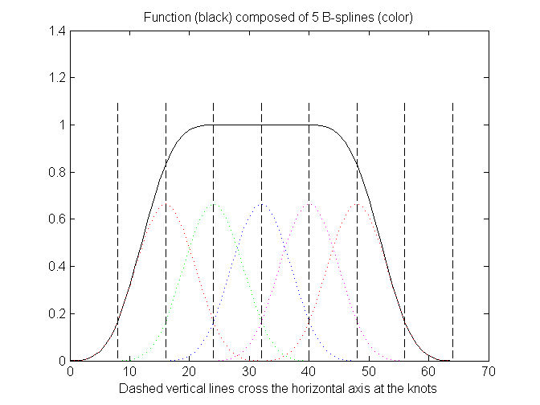

Fig. 3.6 Sum of five shifted cubic B-splines

**3.6.4 LOCALIZATION OF CHANGES:**

The limited nonzero range of each B-spline in the sum results in a localization of changes. If, for example, the 7th coefficient in the weighted sum used is changed to –3, there is a drastic change in those regions to which the 7th B-spline is nonzero.

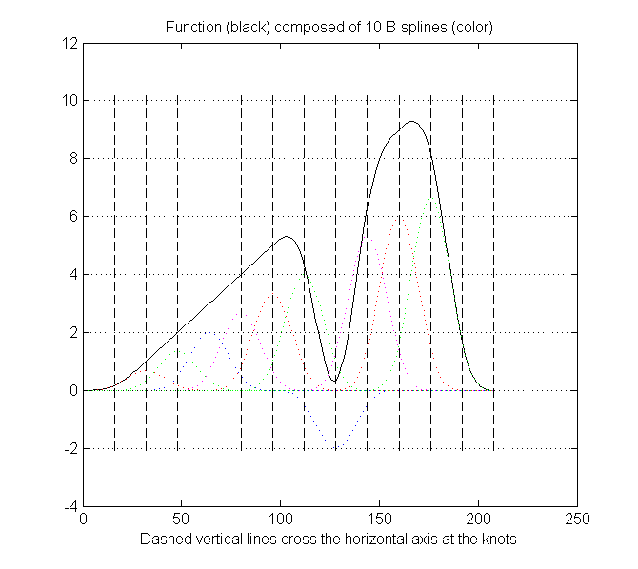

Fig.3.7 Demonstration of the localization of changes

Comparing the two figures in those regions to the left and right of the spline visible below the *x* axis. It should also be noted that the region that is changed by changing the coefficient for a given B-spline equals the region of support of the spline—its nonzero region. It is desired to make only very local changes, meaning changes over only very small regions, then splines with small support should be used. If it is desired to make more global changes, meaning changes over larger regions, then splines with large support should be used. We will learn that in the typical registration algorithm employing B-splines iterative approaches are used in which the first iterations involve B-splines with large support, with the support size decreasing with each successive iteration.

**3.6.5 USE IN IMAGE REGISTRATION:**

It is possible to use these splines to fit a transformation to a given set of point transformations, as we did with the polynomial transformations and the thin-plate transformations, but that is not in fact how these splines are typically used in image registration. Instead, they are typically used not in point-based registration but in intensity-based registration, in which a similarity function based on intensity patterns, as for example mutual information, the sum of absolute intensity differences, or any of the many such functions that we have studied, is maximized or a cost function, which may be simply the negative of a similarity function, is minimized.This is a complex nonlinear optimization problem typically involving hundreds or even thousands of degrees of freedom. Common approaches to this large problem include starting with a small number of B-splines spread over the image, each with a large region of support and finding a transformation. As mentioned above these “large” splines produce global changes. After that a larger number of smaller B-splines, say, eight times as many (a factor of two each in the x, y, and z directions) with a region of support one-eighth the size is used to handle more local changes. This procedure continues for several steps with the spline size decreasing with each step often by a factor of two in each dimension for computational convenience. This progressive increase in the “resolution” of the B-spline array may be accompanied by an increase in the resolution of the image as well. At the beginning, when global changes are made, a low resolution version of the two images might be used in order to reduce the time necessary to calculate the cost function. As the resolution of the B-spline array increases, the resolution of the images used in the cost function increases as well, until at the last step the original images are used at full resolution.

There are many heuristic methods for such minimizations including gird search, steepest descent, Powel’s method, and stochastic methods such as simulated annealing and genetic algorithms. Numerical Recipes is an excellent reference.

**3.6.6 REGULARIZATION:**

Any transformation may exhibit unacceptable spatial behavior. We have seen drastic examples with polynomial transformations, but even the relatively well behaved B-spline may sometimes produce warpings that are overly drastic for a given application. The standard approach for controlling spatial behavior is regularization. Regularization in this context is simply biasing the search for a solution toward more spatially smooth transformations. When a cost function such as one based on image intensity patterns is being minimized, it is easy to perform regularization by adding a term that is large when some less desirable aspect of the warping is large.

**3.7 PENALIZES WARPINGS:**

In which there is stretching or compression. (Instead of squaring the difference, the absolute value may be used as well. A physical model in which this term is always zero is an incompressible liquid (water is an excellent approximation). Liquid motion is highly nonrigid, but its Jacobian is always equal to one. Since much of the body behaves like an incompressible fluid, this regularization makes physical sense.

They are typically justified in terms of the results of some measure or measures of the efficacy of the registrations in a set of experiments used to validate the entire procedure. In the end the combination of warping function, cost function, and minimization method is usually judged experimentally as a whole, and there is rarely only one combination that works. There is a good deal of art that goes with the science of nonrigid registration.

**CHAPTER 4**

**RESULTS AND DISCUSSIONS**

**4.1 MATLAB OUTPUTS:**

The MATLAB outputs are intwo- and three-dimensional plots, images, animation, visualization .Graphics functions include 2-D and 3-D plotting functions to visualize data and communicate results. Customize plots either interactively or programmatically.

**4.2 NORMAL WAVEFORM:**

This figure shows the signal waveform of the normal or unaffected part of breast phantom,

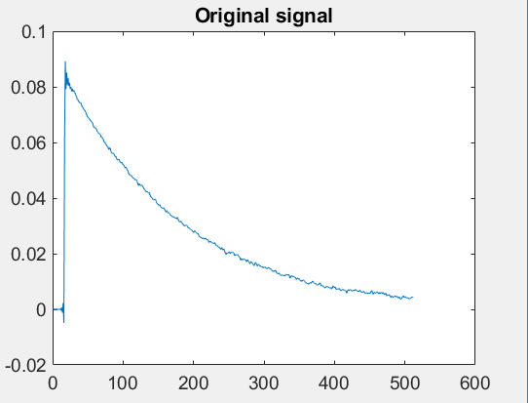

**Fig. 4.1 original signal of unaffected region**

This figure shows the signal waveform of the region in the breast phantom affected by cancer,

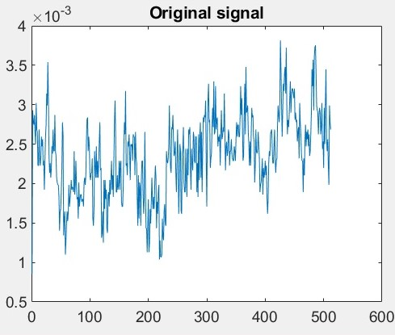

**Fig. 4.2 original signal of affected region**

**4.3 SPLINE TRANSFORMATION:**

This figure shows the spline transformation waveform of the unaffected region in the breast phantom,

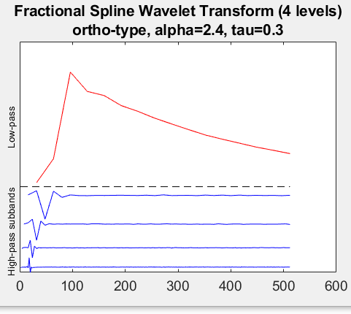

**Fig. 4.3 fractional spline wavelet transform of unaffected region**

This figure shows the spline transformation waveform of tumor affected region in the breast phantom,

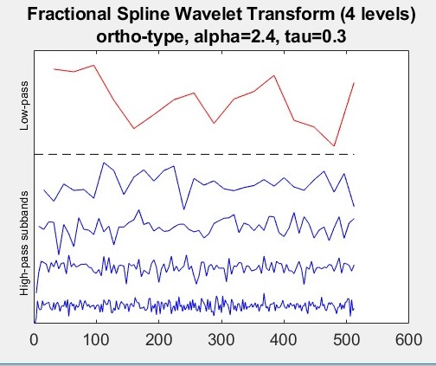

**Fig. 4.4 fractional spline wavelet transform of affected region**

**4.4 SIGNAL COMPARISON:**

This figure shows the comparison waveform of the normal or un affected region with the tumor affected region in the breast phantom with variatons,

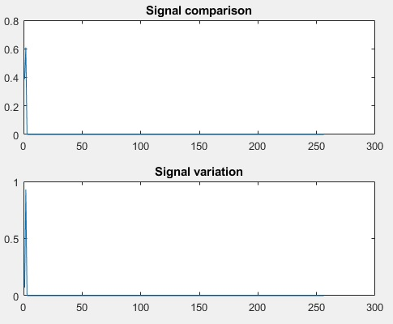

**Fig. 4.5 signal comparison and variation**

**4.5 ADS OUTPUTS:**

ADS provides full, standards-based design and verification with Wireless Libraries and circuit-system-EM co-simulation in an integrated platform.

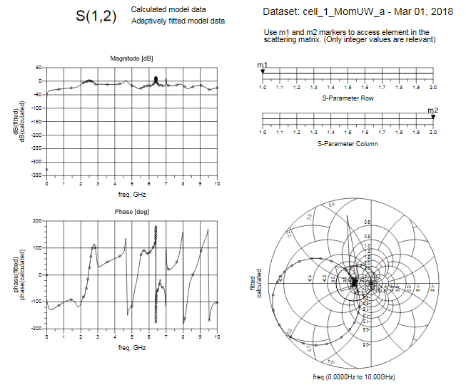

**Fig. 4.6 ADS outputs**

**CHAPTER 5**

**CONCLUSION AND FUTURE WORK**

**CONCLUSION:**

This report has laid the foundation for experimental validation tests of breast cancer detection. We have made progress with building more realistic breast phantoms. We have also presented a basic first set of tests imaging the phantoms with our system.

**FUTURE WORK:**

There are many areas in which this work will continue to be explored in the future: incorporation of the low-noise amplifiers and switches into the system;imaging of phantoms with different sized tumors and with phantoms that have more than one tumor; imaging of phantoms that have glandular tissue;more thorough investigation of imaging using two antennas that areopposite each other, beside each other, oriented along the same plane and oriented 90° apart; imaging using more than one receiving antenna (our system allows for up• to 15); testing of various matching mediums.

**APPENDICES**

**APPENDIX CODING:**

**SPLINE TRANSFORMATION OF UNAFFECTED REGION:**

% Load a 1D signal

%load 1Ddata

[x,fs]=audioread('1.wav');

x=(x(1:512))';

figure(1),plot(x)

set(gca,'fontsize',14)

title('Original signal')

M=length(x); % Should be a power of 2

% Choose a fractional spline wavelet transform

alpha=2.4; % Real value larger than -0.5

tau=0.3; % Real value between -0.5 and +0.5

type='ortho'; % Options are: 1. 'bspline'

% 2. 'ortho'

% 3. 'dual'

[FFTanalysisfilters,FFTsynthesisfilters]=FFTfractsplinefilters(M,alpha,tau,type);

% Perform a fractional spline wavelet transform of the signal

J=4; % Number of decomposition levels

w=FFTwaveletanalysis1D(x,FFTanalysisfilters,J);

% Show a subband

bandnumber=2;

titletext=['Subband ' num2str(bandnumber)];

b0=wextract1D(w,J,bandnumber);

figure(2),clf,plot(b0),colormap(gray(256))

set(gca,'fontsize',14)

title(titletext)

% Show the whole wavelet transform

figure(3),clf,waveletplot1D(w,J)

set(gca,'fontsize',14)

title({['Fractional Spline Wavelet Transform (' num2str(J) ' levels)'],[type '-type, alpha=' num2str(alpha) ', tau=' num2str(tau)]})

% Reconstruction of the signal from its wavelet transform

x0=FFTwaveletsynthesis1D(w,FFTsynthesisfilters,J);

disp(['Resynthesis error: ' num2str(max(abs(x0(:)-x(:))))])

% Reconstruction from only one subband: use of the second output parameter

% from the function wextract2D.m

bandnumber=J+1;

titletext=['Image resynthetized from the lowpass band at depth ' num2str(J)];

[b0,w0]=wextract1D(w,J,bandnumber);

x0=FFTwaveletsynthesis1D(w0,FFTsynthesisfilters,J);

figure(1),a=axis;

figure(4),clf,plot(x0),colormap(gray(256))

set(gca,'fontsize',14)

title(titletext)

axis(a)

% Plot of the synthesis scaling function and the wavelet

[x,y1]=fractsplinefunction(alpha,tau,type,10);

[x,y2]=fractsplinewaveletfunction(alpha,tau,type,10);

figure(5),plot(x,y1,'b',x,y2,'r')

set(gca,'fontsize',14)

legend('scaling function','wavelet')

title([type '-type, alpha=' num2str(alpha) ', tau=' num2str(tau)])

**SPLINE TRANSFORMATION OF AFFECTED REGION:**

% Load a 1D signal

%load 1Ddata

[x,fs]=audioread('2.wav');

x=(x(1:512))';

figure(1),plot(x)

set(gca,'fontsize',14)

title('Original signal')

M=length(x); % Should be a power of 2

% Choose a fractional spline wavelet transform

alpha=2.4; % Real value larger than -0.5

tau=0.3; % Real value between -0.5 and +0.5

type='ortho'; % Options are: 1. 'bspline'

% 2. 'ortho'

% 3. 'dual'

[FFTanalysisfilters,FFTsynthesisfilters]=FFTfractsplinefilters(M,alpha,tau,type);

% Perform a fractional spline wavelet transform of the signal

J=4; % Number of decomposition levels

w=FFTwaveletanalysis1D(x,FFTanalysisfilters,J);

% Show a subband

bandnumber=2;

titletext=['Subband ' num2str(bandnumber)];

b0=wextract1D(w,J,bandnumber);

figure(2),clf,plot(b0),colormap(gray(256))

set(gca,'fontsize',14)

title(titletext)

% Show the whole wavelet transform

figure(3),clf,waveletplot1D(w,J)

set(gca,'fontsize',14)

title({['Fractional Spline Wavelet Transform (' num2str(J) ' levels)'],[type '-type, alpha=' num2str(alpha) ', tau=' num2str(tau)]})

% Reconstruction of the signal from its wavelet transform

x0=FFTwaveletsynthesis1D(w,FFTsynthesisfilters,J);

disp(['Resynthesis error: ' num2str(max(abs(x0(:)-x(:))))])

% Reconstruction from only one subband: use of the second output parameter

% from the function wextract2D.m

bandnumber=J+1;

titletext=['Image resynthetized from the lowpass band at depth ' num2str(J)];

[b0,w0]=wextract1D(w,J,bandnumber);

x0=FFTwaveletsynthesis1D(w0,FFTsynthesisfilters,J);

figure(1),a=axis;

figure(4),clf,plot(x0),colormap(gray(256))

set(gca,'fontsize',14)

title(titletext)

axis(a)

% Plot of the synthesis scaling function and the wavelet

[x,y1]=fractsplinefunction(alpha,tau,type,10);

[x,y2]=fractsplinewaveletfunction(alpha,tau,type,10);

figure(5),plot(x,y1,'b',x,y2,'r')

set(gca,'fontsize',14)

legend('scaling function','wavelet')

title([type '-type, alpha=' num2str(alpha) ', tau=' num2str(tau)])

**DIAGNOSIS:**

% read two images

Image1 = audioread(uigetfile); % Image 1

Image2 = audioread(uigetfile); % Image 2

% convert images to type double (range from from 0 to 1 instead of from 0 to 255)

Imaged1 = (Image1);

Imaged2 = (Image2);

% reduce three channel [ RGB ] to one channel [ grayscale ]

Imageg1 = (Imaged1);

Imageg2 = (Imaged2);

% Calculate the Normalized Histogram of Image 1 and Image 2

hn1 = imhist(Imageg1)./numel(Imageg1);

hn2 = imhist(Imageg2)./numel(Imageg2);

%subplot(2,2,1);plot(Image1)

%subplot(2,2,2);subimage(Image2)

subplot(2,1,1);plot(hn1)

title('Signal comparison');

subplot(2,1,2);plot(hn2)

title('Signal variation');

% Calculate the histogram error

f = sum((hn1 - hn2).^2);

disp(f) %display the result to console

**REFERENCE**

[1] C. Hahn, and S. Noghanian, "Heterogeneous breast phantom development for microwave imaging using regression models," *Int. J. Biomed. Imag., vol. 2012, p. 803607-12, 2012.*

[2] I. Ünal, B. Türetken, K. Sürmeli, and C. Canbay, "An experimental microwave imaging system for breast tumor detection on layered phantom model," *Gener. Assem. Scient. Sym., Aug. 13-20, p. 1-4, 2011.*

[3] J. Garrett, and E. Fear, "A New Breast Phantom With a Durable Skin Layer for Microwave Breast Imaging," *IEEE Trans. Antennas Propag.,* vol. 63, p. 1693-1700, 2015.

[4] M.J. Burfeindt, T.J. Colgan, R.O. Mays, J.D. Shea, N. Behdad, B.D. Van Veen, and S.C. Hagness, "MRI-Derived 3-D-Printed Breast Phantom for Microwave Breast Imaging Validation," *IEEE Antennas Wireless Propag. Lett., vol. 11, p. 1610-1613, 2012.*

[5] N. Joachimowicz, C. Conessa, T. Henriksson, and B. Duchene, "Breast Phantoms for Microwave Imaging," *IEEE Antennas Wireless Propag. Lett., vol. 13, p. 1333-1336, 2014.*

[6] Y. Yuan, C. Wyatt, P. MacCarini, P. Stauffer, O. Craciunescu, J. MacFall, M. Dewhirst, and S.K. Das, "A heterogeneous human tissue mimicking phantom for RF heating and MRI thermal monitoring verification," *Phys. Med. Biol., vol. 57, p. 2021-2037, 2012*